This set of Engineering Physics Multiple Choice Questions & Answers (MCQs) focuses on “Ruby Laser”.

1. Which of the following is a three-level laser?  
a) ND: YAG  
b) Ruby  
c) He-Ne  
d) Semiconductor laser  
View Answer

Answer: b  
Explanation: Ruby laser is a three-level laser. Ruby crystal is a crystal of Al2O3 with some Al3+ ions replaced by Cr3+ ions. The energy levels of Cr3+ are responsible for lasing action.

2. The lifetime of meta-stable state in a Ruby laser is \_\_\_\_\_\_\_\_\_\_\_  
a) 10-8s  
b) 10-6s  
c) 10-3s  
d) 10-2s  
View Answer

Answer: c  
Explanation: The second energy level in a Ruby laser is the meta-stable state. It’s lifetime is 10-3 s. It is between this state and the ground state that the lasing action takes place.

3. The ends of the ruby rod works as \_\_\_\_\_\_\_\_\_\_  
a) Pumping source  
b) Active medium  
c) Cavity mirrors  
d) Energy levels  
View Answer

Answer: c  
Explanation: In the ruby lase, one end of the ruby rod is completely polished while the other end is made partially reflecting. Hence, the two ends work as the cavity mirrors.

**Subscribe Now:**[**Engineering Physics II Newsletter**](javasript:;)**|**[**Important Subjects Newsletters**](https://www.sanfoundry.com/newsletter/)

advertisement

4. The pumping mechanism used in Ruby rod is \_\_\_\_\_\_\_\_\_\_  
a) Optical Pumping  
b) Electrical Excitation  
c) Chemical pumping  
d) Thermal pumping  
View Answer

Answer: a  
Explanation: The Ruby rod is placed inside a xenon flash lamp so as to provide sufficient amount of light to cause excitation of atoms. This kind of pumping is called optical pumping.

5. Which material is used for cooling of the ruby rod for efficient continuous operation?  
a) CFC  
b) Liquid helium  
c) Liquid oxygen  
d) Liquid Nitrogen  
View Answer

Answer: d  
Explanation: A large amount of energy is dissipated in the ruby rod. Thus, it has to be cooled for efficient continuous operation. For this purpose, liquid nitrogen is used.

**Participate in**[**Engineering Physics II Certification Contest**](https://rank.sanfoundry.com/engineering-physics-ii-certification-contest/)**of the Month Now!**

6. The laser beam is emitted in the form of \_\_\_\_\_\_\_\_\_\_  
a) Fluctuating radiations  
b) Continuous spectrum  
c) Pulsed output  
d) Exponentially decreasing intensity  
View Answer

Answer: c  
Explanation: The laser output observed in a Ruby laser is pulsed. This is so, as the flash lamp operation is pulsed. There are spikes in the ruby laser output, lasting a few milliseconds.

7. The following graph represents the output for which type of LASER?  
[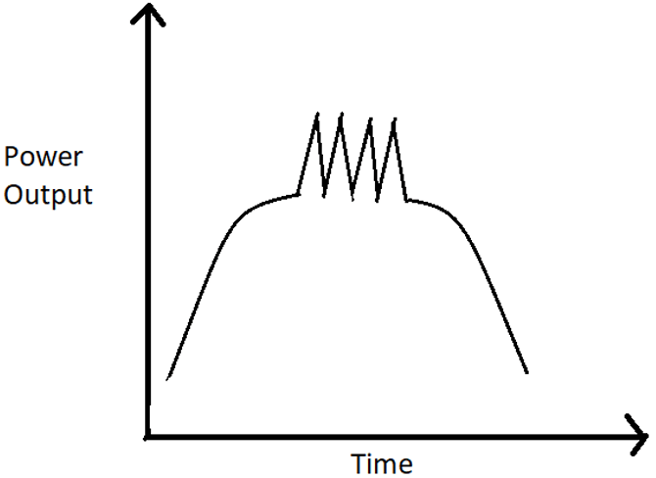](https://www.sanfoundry.com/wp-content/uploads/2019/11/engineering-physics-questions-answers-ruby-laser-q7.png)  
a) He-Ne Laser  
b) Ruby Laser  
c) ND: YAG laser  
d) Semiconductor Diode laser  
View Answer

Answer: b  
Explanation: Let there be three energy levels E1, E2 and E3 with E3 > E2 > E1.  
Now, when population inversion is achieved between E1 and E2, simulates emission starts and coherent laser light is produced with a sharp peak at 6943 A. It depopulates the level E2 at faster rate than pump rate, stopping laser action momentarily. Before the output falls to zero, the process starts repeating. Due to this, the output consists a series of spikes.

advertisement

8. For a Ruby laser, the coherence time t = 10-10 s. The degree of Monochromaticity is \_\_\_\_\_\_\_\_\_\_  
a) 0.13 X 10-4  
b) 0.24 X 10-4  
c) 0.35 X 10-4  
d) 0.47 X 10-4  
View Answer

Answer: a  
Explanation: Coherence time, t = 10-10 s  
Therefore, Δv = 1/t = 1010 Hz  
Now, λo = 6940 Å, vo = 7.2 X 1014 Hz  
Monochromaticity = Δvv0  
= 0.13 X 10-4.

9. What will be the relative population of atoms in a ruby layer that produces a light beam of wavelength 6943 Å at 300 K.  
a) 5 X 10-31  
b) 6 X 10-31  
c) 7 X 10-31  
d) 8 X 10-31  
View Answer

Answer: d  
Explanation: The relative population of atoms in two states with energy E1 and E2 is given by  
N2/N1 = e−(E2−E1)kT  
E2 – E1 = hv  
= hc/λ  
= 1.79 eV  
Therefore, N2/N1 = e−1.79kT  
= e-69.3  
= 8 X 10-31.

advertisement

10. What is the wavelength of the emitted laser in a Ruby laser?  
a) 694 nm  
b) 650 nm  
c) 780 nm  
d) 754 nm  
View Answer

Answer: a  
Explanation: Ruby laser emits visible light. It is a three-level laser. The emitted radiations have a wavelength of 694.3 nm, which represents the red color. The output observed in a Ruby laser is spiked.

11. The energy levels of which ion/atom/molecule are responsible for lasing action?  
a) Al3+  
b) Cr3+  
c) Al2O3  
d) Cr2O3  
View Answer

Answer: b  
Explanation: The energy levels of Cr3+ are responsible for the lasing action. It is the three energy levels of Cr3+ ion, that the population inversion takes place and light is emitted via stimulated emission.

1. Which of the following is a four-level laser?  
a) ND: YAG  
b) Ruby  
c) He-Ne  
d) Argon laser  
View Answer

Answer: c  
Explanation: He-Ne laser is a four-level laser. Whenever an electric discharge is passed through the gas, the helium atoms gets to higher energy states, as the concentration of helium atoms is higher. It was one of the first successfully operated laser.

2. The difference between He-Ne Laser is \_\_\_\_\_\_\_\_\_\_  
a) It gives pulsed output  
b) It gives a non-continuous laser beam  
c) It gives a continuous laser beam  
d) No difference  
View Answer

Answer: c  
Explanation: As we know, the ruby laser beam is discontinuous and pulsed. However, the He-Ne laser beam is a continuous laser beam. Also, it is a four-level laser while ruby laser is a three-level laser.

3. He-Ne laser is a type of \_\_\_\_\_\_\_\_\_\_\_\_  
a) Solid laser  
b) Liquid laser  
c) Gas laser  
d) Diode laser  
View Answer

Answer: c  
Explanation: He-Ne laser is the most widely used laser. It was the first continuous laser generated. Gas lasers are less prone to damage by overheating, as compared to solid laser.

**Note: Join free Sanfoundry classes at**[**Telegram**](https://t.me/sanfoundryclasses/)**or [Youtube](https://www.youtube.com/c/SanfoundryOfficial/?sub_confirmation=1" \t "_blank)**

advertisement

4. Which pumping method is used in He-Ne laser?  
a) Optical Pumping  
b) Electrical Excitation  
c) Chemical Pumping  
d) Direct Conversion  
View Answer

Answer: b  
Explanation: Generally, in He-Ne laser, an electric discharge is used to excite the atoms of the active medium. This process is known as Electrical Excitation and is normally used in gas lasers.

5. The He-Ne laser operates at a wavelength of \_\_\_\_\_\_\_\_\_\_\_\_  
a) 540 nm  
b) 632 nm  
c) 690 nm  
d) 717 nm  
View Answer

Answer: b  
Explanation: The helium-neon laser operates at a wavelength of 632.8 nanometers (nm), in the red portion of the visible spectrum. It is the most widely used gas laser.

**Take Engineering Physics II Practice Tests - Chapterwise!  
Start the Test Now:**[**Chapter 1,**](https://rank.sanfoundry.com/engineering-physics-ii-practice-test-1/)[**2,**](https://rank.sanfoundry.com/engineering-physics-ii-practice-test-2/)[**3,**](https://rank.sanfoundry.com/engineering-physics-ii-practice-test-3/)[**4,**](https://rank.sanfoundry.com/engineering-physics-ii-practice-test-4/)[**5,**](https://rank.sanfoundry.com/engineering-physics-ii-practice-test-5/)[**6,**](https://rank.sanfoundry.com/engineering-physics-ii-practice-test-6/)[**7,**](https://rank.sanfoundry.com/engineering-physics-ii-practice-test-7/)[**8,**](https://rank.sanfoundry.com/engineering-physics-ii-practice-test-8/)[**9,**](https://rank.sanfoundry.com/engineering-physics-ii-practice-test-9/)[**10**](https://rank.sanfoundry.com/engineering-physics-ii-practice-test-10/)

6. The number of photons emitted for a 2.5 mW He-Ne laser is \_\_\_\_\_\_\_\_\_\_  
a) 4.9 X 1015  
b) 5.9 X 1015  
c) 6.9 X 1015  
d) 7.9 X 1015  
View Answer

Answer: b  
Explanation: We know, for a He-Ne laser, λ = 6328 Å = 6.328 X 10-7 m  
Power = 2.5 mW = 2.5 X 10-3 E  
Energy = Power X Time = 0.0025 X 1  
= 0.0025  
Number of photons in each pulse = Energy X λ / hc  
= 0.0025 X 6.6 X 10-7/6.6 X 10-34 X 3 X 108  
= 7.9 X 1015.

7. The output of a He-Ne laser has pulse duration of 15 ms and average output power of 1 W per pulse. How much energy is released per pulse?  
a) 5 mJ  
b) 10 mJ  
c) 15 mJ  
d) 20 mJ  
View Answer

Answer: c  
Explanation: As we know, Energy = Power X Time  
= 1 W X 15 X 10-3 s  
= 15 mJ.

advertisement

8. When the transition takes place from En6 -> En5, what is the wavelength of produced beam?  
a) 6328 Å  
b) 33913 Å  
c) 11523 Å  
d) 7550 Å  
View Answer

Answer: b  
Explanation: When the lasing transition is from En6 -> En5, it produces a beam of 33913 Å. The opper level is same in this case and in the 6328 Å transition.

9. He-Ne laser is used in Holography.  
a) True  
b) False  
View Answer

Answer: a  
Explanation: He-Ne laser is highly coherent and monochromatic. Due to this, it is used in holography, spectrometers, prints, scanners, etc. It is widely used in Laboratories.

advertisement

10. Which of the following shows the laser transition in Neon in He-Ne laser?  
a) [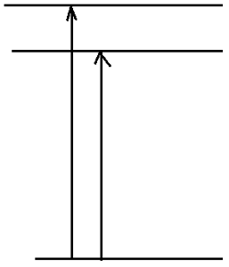](https://www.sanfoundry.com/wp-content/uploads/2019/11/engineering-physics-questions-answers-helium-neon-laser-q10a.png)  
b) [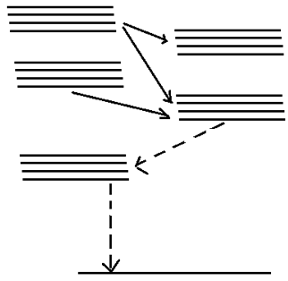](https://www.sanfoundry.com/wp-content/uploads/2019/11/engineering-physics-questions-answers-helium-neon-laser-q10b.png)  
c) [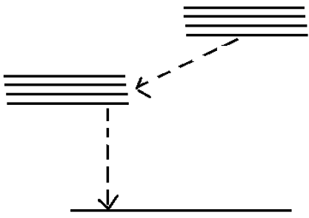](https://www.sanfoundry.com/wp-content/uploads/2019/11/engineering-physics-questions-answers-helium-neon-laser-q10c.png)  
d) [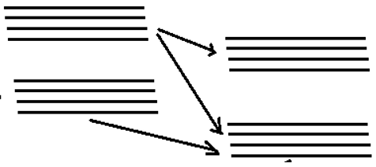](https://www.sanfoundry.com/wp-content/uploads/2019/11/engineering-physics-questions-answers-helium-neon-laser-q10d.png)  
View Answer

Answer: b  
Explanation: The transition shown in the following figure is the correct transition that takes place in the Ne atoms. Between two or more layer, as soon as population inversion is achieved, the lasing action starts.  
[](https://www.sanfoundry.com/wp-content/uploads/2019/11/engineering-physics-questions-answers-helium-neon-laser-q10b.png)

**Engineering Physics Questions and Answers – Carbon Dioxide Laser and Semiconductor Laser**

**« [Prev](https://www.sanfoundry.com/engineering-physics-questions-answers-helium-neon-laser/)**

[**Next**](https://www.sanfoundry.com/engineering-physics-questions-answers-properties-x-rays/)**»**

This set of Engineering Physics Puzzles focuses on “Carbon Dioxide Laser and Semiconductor Laser”.

1. What is the wavelength of the emitted laser by a carbon dioxide?  
a) 9.4 μm  
b) 10.6 μm  
c) 11.4 μm  
d) 12.5 μm  
View Answer

Answer: b  
Explanation: The radiations emitted in a CO2 laser has a wavelength of 10.6 μm. It is a four-level laser. The transition takes place between the different vibrational states of the molecule.

2. Which of the following is a characteristic of semiconductor lasers?  
a) Output in Visible region  
b) High Efficiency  
c) Output in UV region  
d) Pulsed output  
View Answer

Answer: b  
Explanation: Semiconductor lasers such as GaAs, InP, InSb etc. are used extensively because of their high efficiency. Also, they can be employed in optical communications with ease.

3. In the CO2 molecular gas laser, transition takes place between the \_\_\_\_\_\_\_\_\_\_\_\_\_\_  
a) Molecular states  
b) Atomic states  
c) Vibrational states  
d) Energy states  
View Answer

Answer: c  
Explanation: In the CO2 molecular gas laser, transition takes place between the vibrational states of Carbon dioxide molecules. It is a very efficient laser.

**Subscribe Now:**[**Engineering Physics II Newsletter**](javasript:;)**|**[**Important Subjects Newsletters**](https://www.sanfoundry.com/newsletter/)

advertisement

4. Which of the following is a four-level laser?  
a) ND: YAG  
b) Ruby  
c) Argon laser  
d) CO2 laser  
View Answer

Answer: c  
Explanation: The CO2 laser is a very efficient laser. It is a four-level laser and it operates at 10.6 μm in the far IR region. The active medium is a gas mixture of CO2, N2 and He.

5. Which of the following gas is not a part of the active medium in a CO2 laser?  
a) CO2  
b) N2  
c) He  
d) O2  
View Answer

Answer: d  
Explanation: The active medium of a CO2 laser consists of a mixture of CO2, N2 and He. It is the vibrational transition in the CO2 that results in the lasing action.

**Become**[**Top Ranker in Engineering Physics II**](https://rank.sanfoundry.com/top-rankers-engineering-physics-ii/)**Now!**

6. The highest powered CO2 laser had a power of \_\_\_\_\_\_\_\_\_  
a) 1 W  
b) 10 W  
c) 1000 W  
d) 10000 W  
View Answer

Answer: c  
Explanation: Light from a CO2 laser is powerful enough to cut many materials, including cloth, wood and paper; the most powerful CO2 lasers are used for machining steel and other metals. The highest-powered CO2 lasers run over 1,000 W.

7. The active medium of a semiconductor diode is the junction of the forward biased P-N diode.  
a) True  
b) False  
View Answer

Answer: a  
Explanation: When the p-side of a semiconductor diode is connected to the positive terminal of the battery and the n-side to the negative terminal, the diode is said to be forward biased. A semiconductor laser is essentially a semiconductor diode, where the active medium is the forward biased p-n junction.

advertisement

8. Semiconductors lasers do not need mirrors to form optical cavity.  
a) True  
b) False  
View Answer

Answer: a  
Explanation: Semiconductor lasers do not require two external mirrors to form an optical cavity. Reflection from the cleaved ends of the semiconductor is enough to produce lasing.

**Engineering Physics Questions and Answers – Population Inversion**

**« [Prev](https://www.sanfoundry.com/engineering-physics-questions-answers-einstein-coefficients/)**

[**Next**](https://www.sanfoundry.com/engineering-physics-questions-answers-pumping-mechanism/)**»**

This set of Engineering Physics Multiple Choice Questions & Answers (MCQs) focuses on “Population Inversion”.

1. During Population inversion, which of the following processed is dominant?  
a) Stimulated Absorption  
b) Stimulated Emission  
c) Spontaneous Emission  
d) Spontaneous Absorption  
View Answer

Answer: b  
Explanation: LASER is a short form of Light Amplification by Stimulated Emission of Radiations. Stimulated Emission is the process by which amplification of radiations takes place. Hence, Laser operation requires stimulated emission to be dominant.

2. The relationship between N1 and N2 for stimulated emission to be dominant is \_\_\_\_\_\_\_\_\_\_\_  
a) N1 = N2  
b) N1 > N2  
c) N2 > N1  
d) No such relationship  
View Answer

Answer: c  
Explanation: In this case, the population of atoms in the exited state is more than that in the ground state. This condition is known as population inversion and in this case, stimulated emission is dominant.

3. The ratio of N2 and N1 is given by \_\_\_\_\_\_\_\_\_\_\_  
a) e−hvkT  
b) ehvkT  
c) e−hvT  
d) ehvT  
View Answer

Answer: a  
Explanation: From Maxwell Boltzmann law we know that, N = N0e-E/kT. Hence from there we can say that N2 = N0e-E2/kT and N1 = N0e-E1/kT.  
Therefore, N2/N1 = e-(E2 – E1)/kT  
= e−hvkT.

[**Sanfoundry Certification Contest**](https://www.sanfoundry.com/contests/)**of the Month is Live. 100+ Subjects. Participate Now!**

advertisement

4. During pumping, the atoms are exited to \_\_\_\_\_\_\_\_\_\_\_  
a) Higher Exited States  
b) Lower Energy states  
c) Meta Stable states  
d) Not Excited  
View Answer

Answer: c  
Explanation: Pumping is the process in which the atoms from the lower energy states are excited to meta-stable states by some external source so as to create population inversion.

5. At the state when N1 > N2, the intensity of light wave \_\_\_\_\_\_\_\_\_\_\_\_\_  
a) Increases linearly  
b) Increases exponentially  
c) Decreases linearly  
d) Decreases exponentially  
View Answer

Answer: d  
Explanation: When N1 > N2, the population of atoms in the ground state is higher than that in the exited state. In this case, absorption is dominant and hence, the intensity of light wave decreases exponentially.

**Check this:**[**Engineering Physics II Books**](https://www.sanfoundry.com/best-reference-books-engineering-physics/)

6. To achieve optical amplifications, it is essential to create a non-equilibrium distribution of atoms.  
a) True  
b) False  
View Answer

Answer: a  
Explanation: We know, N2/N1 = e−hvkT. Thus, in normal situation, N1 > N2 for E1 < E2. Thus, to achieve lasing action, non-equilibrium distribution of atoms in such a way that the population of the upper energy is greater than that of the lower energy level.

7. What will be the relative population of atoms in a ruby layer that produces a light beam of wavelength 6943 Å at 300 K.  
a) 5 X 10-31  
b) 6 X 10-31  
c) 7 X 10-31  
d) 8 X 10-31  
View Answer

Answer: d  
Explanation: The relative population of atoms in two states with energy E1 and E2 is given by  
N2/N1 = e−(E2−E1)kT  
E2 – E1 = hv  
= hc/λ  
= 1.79 eV  
Therefore, N2/N1 = e−1.79kT  
= e-69.3  
= 8 X 10-31.

advertisement

8. What will be the relative population of atoms in a ruby layer that produces a light beam of frequency 6 X 1014 Hz at 300 K.  
a) e-85  
b) e-90  
c) e-95  
d) e-100  
View Answer

Answer: c  
Explanation: We know, N2/N1 = e−hvkT  
Here, v = 6 X 1014 Hz and T = 300 K  
hv/kT = 6.6 X 10-34 X 6 X 1014/ 8.61 X 10-5 X 300  
≈ 95  
Therefore, N2/N1 = e-95.

9. Between which two layers, population inversion takes place?  
[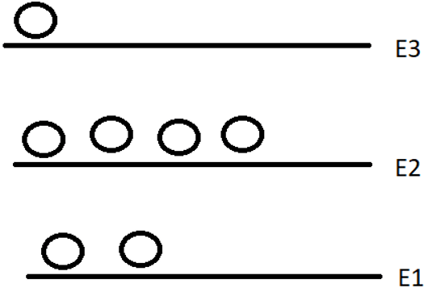](https://www.sanfoundry.com/wp-content/uploads/2019/11/engineering-physics-questions-answers-population-inversion-q9.png)  
a) E1 and E2  
b) E1 and E3  
c) E2 and E2  
d) Neither energy levels  
View Answer

Answer: a  
Explanation: Between E2 and E1, there are more electrons in E2 level and it also has higher energy. Hence, population inversion exists between E2 and E1.

advertisement

10. Which of the following is a four-level laser?  
a) ND: YAG  
b) Ruby  
c) He-Ne  
d) Semiconductor laser  
View Answer

Answer: c  
Explanation: He-Ne laser is a four-level laser. Whenever an electric discharge is passed through the gas, the helium atoms gets to higher energy states, as the concentration of helium atoms is higher to achieve population inversion

9. The following figure shows the laser spectrum for \_\_\_\_\_\_\_\_  
[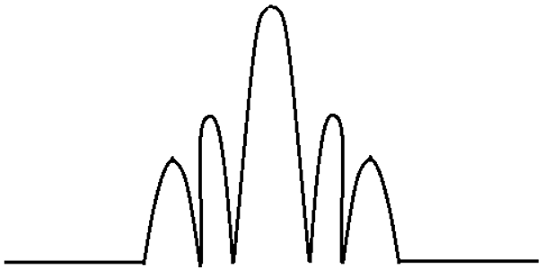](https://www.sanfoundry.com/wp-content/uploads/2019/11/engineering-physics-puzzles-q9.png)  
a) CO2 Laser  
b) Fabry-Pot Semiconductor Laser  
c) DFB semiconductor laser  
d) FBG semiconductor laser  
View Answer

Answer: b  
Explanation: Fabry-Pot semiconductor laser is a type of semiconductor laser which is characterized by the use of the cleavage plane of a laser crystal for reflection of the light emitted in the active layer. It’s lasing spectrum observed is as shown in the figure.

advertisement

10. Where is ND: YAG most commonly used?  
a) Cosmetic Surgery  
b) Welding  
c) Photography  
d) Optical Communications  
View Answer

Answer: a  
Explanation: ND: YAG is most commonly used for cosmetic energy because it has the property of maximum energy absorption by the target (hair or lesion) with minimum absorption by the surrounding skin structures.

11. In which region of the electromagnetic spectrum, does the semiconductor laser lies?  
a) Visible Region  
b) UV Region  
c) Microwave Region  
d) Infrared Region  
View Answer

Answer: d  
Explanation: In the gallium arsenide laser, the wavelength of the emitted laser is around 845 nm to 905 nm, which lies in the infrared region of the electromagnetic spectrum.

12. The following graph shows the physical gain for which kind of laser?  
[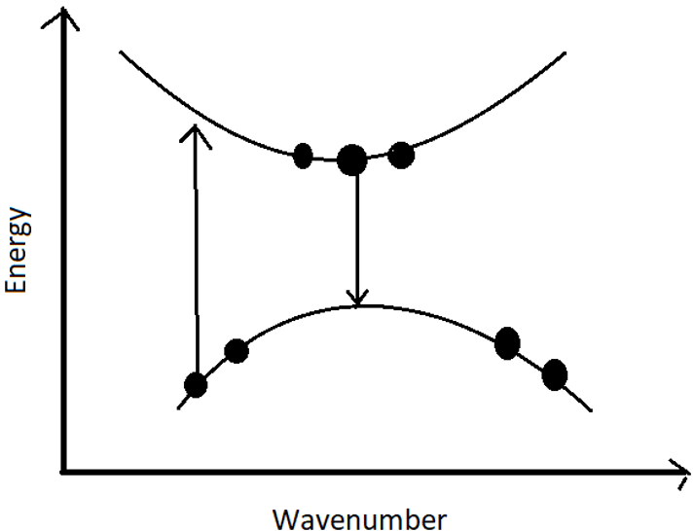](https://www.sanfoundry.com/wp-content/uploads/2019/11/engineering-physics-questions-answers-carbon-dioxide-laser-semiconductor-laser-q12.png)  
a) CO2 Laser  
b) Semiconductor Laser  
c) Helium Laser  
d) Ruby Laser  
View Answer

Answer: b  
Explanation: The given figure shows the physical gain for a semiconductor laser. The upper band is the conduction band while the lower one is the valence band. The lasing action is taking place between the two bands.

1. What is the electromagnetic force? a) The force that holds the nucleus together b) The force that binds atoms to form molecules c) The force that acts between electrically charged particles d) The force that results from the interaction of magnetic fields

Answer: c

1. What is the unit of electric charge? a) Coulomb b) Volt c) Ampere d) Joule

Answer: a

1. What is the speed of light in a vacuum? a) 3.00 x 10^8 m/s b) 2.99 x 10^8 m/s c) 3.10 x 10^8 m/s d) 2.90 x 10^8 m/s

Answer: a

1. What is Faraday's law of electromagnetic induction? a) The induced emf in a circuit is equal to the rate of change of the magnetic flux through the circuit b) The force between two charges is directly proportional to the product of their charges and inversely proportional to the square of the distance between them c) The total electric flux through any closed surface is proportional to the total charge enclosed within the surface d) The potential difference between two points in a circuit is equal to the product of the current flowing between them and the resistance of the circuit

Answer: a

1. Which of the following statements is true about electromagnetic waves? a) They require a medium to propagate b) They are transverse waves c) They travel at the speed of sound d) They are not affected by electric fields

Answer: b

I hope these questions help!

1. What is the electromagnetic force? a) The force that holds the nucleus together b) The force that binds atoms to form molecules c) The force that acts between electrically charged particles d) The force that results from the interaction of magnetic fields

Answer: c

1. What is the unit of electric charge? a) Coulomb b) Volt c) Ampere d) Joule

Answer: a

1. What is the speed of light in a vacuum? a) 3.00 x 10^8 m/s b) 2.99 x 10^8 m/s c) 3.10 x 10^8 m/s d) 2.90 x 10^8 m/s

Answer: a

1. What is Faraday's law of electromagnetic induction? a) The induced emf in a circuit is equal to the rate of change of the magnetic flux through the circuit b) The force between two charges is directly proportional to the product of their charges and inversely proportional to the square of the distance between them c) The total electric flux through any closed surface is proportional to the total charge enclosed within the surface d) The potential difference between two points in a circuit is equal to the product of the current flowing between them and the resistance of the circuit

Answer: a

1. Which of the following statements is true about electromagnetic waves? a) They require a medium to propagate b) They are transverse waves c) They travel at the speed of sound d) They are not affected by electric fields

Answer: b

I hope these questions help!

20 mcq question from laser

Sure, here are 20 multiple choice questions on lasers:

1. What does the acronym LASER stand for? a) Light amplification by stimulated emission of radiation b) Light absorption by stimulated emission of radiation c) Light amplification by spontaneous emission of radiation d) Light absorption by spontaneous emission of radiation

Answer: a

1. What is a laser gain medium? a) The material that produces the laser beam b) The material that amplifies the laser beam c) The material that absorbs the laser beam d) The material that reflects the laser beam

Answer: b

1. What is the active medium in a helium-neon laser? a) Helium b) Neon c) Carbon dioxide d) Nitrogen

Answer: b

1. What is the wavelength of visible red light in nanometers? a) 400 nm b) 500 nm c) 600 nm d) 700 nm

Answer: d

1. Which type of laser is used in eye surgery? a) Carbon dioxide laser b) Excimer laser c) Nd:YAG laser d) Ruby laser

Answer: c

1. What is the laser threshold? a) The point at which the laser beam is fully collimated b) The point at which the laser beam is first generated c) The minimum amount of pump power needed to achieve laser action d) The maximum amount of pump power that can be applied to the laser gain medium

Answer: c

1. What is the primary advantage of using a diode laser over other types of lasers? a) Diode lasers are smaller and more compact b) Diode lasers are more powerful c) Diode lasers produce a wider range of wavelengths d) Diode lasers are more efficient

Answer: a

1. What is the difference between a continuous-wave laser and a pulsed laser? a) Continuous-wave lasers emit a steady beam of light, while pulsed lasers emit short bursts of light b) Pulsed lasers emit a steady beam of light, while continuous-wave lasers emit short bursts of light c) Continuous-wave lasers produce a wider range of wavelengths, while pulsed lasers produce a narrower range of wavelengths d) Pulsed lasers produce a wider range of wavelengths, while continuous-wave lasers produce a narrower range of wavelengths

Answer: a

1. What is the laser linewidth? a) The range of wavelengths produced by the laser b) The number of photons emitted by the laser per second c) The width of the laser beam at its focus d) The range of frequencies produced by the laser

Answer: d

1. What is mode locking? a) The process of adjusting the laser cavity to produce a specific mode of operation b) The process of aligning the laser beam to produce a collimated output c) The process of producing ultra-short laser pulses by synchronizing multiple longitudinal modes of the laser cavity d) The process of increasing the intensity of the laser beam by increasing the number of photons emitted per second

Answer: c

1. What is the principle behind Q-switching? a) The use of a fast shutter to control the output of the laser b) The use of a saturable absorber to control the output of the laser c) The use of a prism to control the output of the laser d) The use of a frequency doubler to control the output of the laser

Answer: b

This set of Electromagnetic Theory Multiple Choice Questions & Answers (MCQs) focuses on “Curl”.

1. Curl is defined as the angular velocity at every point of the vector field. State True/False.  
a) True  
b) False  
View Answer

Answer: a  
Explanation: Curl is defined as the circulation of a vector per unit area. It is the cross product of the del operator and any vector field. Circulation implies the angular at every point of the vector field. It is obtained by multiplying the component of the vector parallel to the specified closed path at each point along it, by the differential path length and summing the results.

2. The curl of curl of a vector is given by,  
a) Div(Grad V) – (Del)2V  
b) Grad(Div V) – (Del)2V  
c) (Del)2V – Div(Grad V)  
d) (Del)2V – Grad(Div V)  
View Answer

Answer: b  
Explanation: Curl (Curl V) = Grad (Div V) – (Del)2V is a standard result of the curl operation.

3. Which of the following theorem use the curl operation?  
a) Green’s theorem  
b) Gauss Divergence theorem  
c) Stoke’s theorem  
d) Maxwell equation  
View Answer

Answer: c  
Explanation: The Stoke’s theorem is given by ∫ A.dl = ∫Curl(A).ds, which uses the curl operation. There can be confusion with Maxwell equation also, but it uses curl in electromagnetics specifically, whereas the Stoke’s theorem uses it in a generalised manner. Thus the best option is Stoke’s theorem.

[**Sanfoundry Certification Contest**](https://www.sanfoundry.com/contests/)**of the Month is Live. 100+ Subjects. Participate Now!**

advertisement

4. The curl of a curl of a vector gives a  
a) Scalar  
b) Vector  
c) Zero value  
d) Non zero value  
View Answer

Answer: b  
Explanation: Curl is always defined for vectors only. The curl of a vector is a vector only. The curl of the resultant vector is also a vector only.

5. Find the curl of the vector and state its nature at (1,1,-0.2)  
F = 30 i + 2xy j + 5xz2 k  
a) √4.01  
b) √4.02  
c) √4.03  
d) √4.04  
View Answer

Answer: d  
Explanation: Curl F = -5z2 j + 2y k. At (1,1,-0.2), Curl F = -0.2 j + 2 k. |Curl F| = √(-0.22+22) = √4.04.

**Check this:**[**Electrical Engineering MCQs**](https://www.sanfoundry.com/electrical-engineering-questions-answers/)**|**[**Electrical Engineering Books**](https://www.sanfoundry.com/best-reference-books-btech-electrical-engineering/)

6. Is the vector is irrotational. E = yz i + xz j + xy k  
a) Yes  
b) No  
View Answer

Answer: a  
Explanation: Curl E = i(Dy(xy) – Dz(xz)) – j (Dx(xy) – Dz(yz)) + k(Dx(xz) – Dy(yz)) =  
i(x – x) – j(y – y) + k(z – z) = 0  
Since the curl is zero, the vector is irrotational or curl-free.

7. Find the curl of A = (y cos ax)i + (y + ex)k  
a) 2i – ex j – cos ax k  
b) i – ex j – cos ax k  
c) 2i – ex j + cos ax k  
d) i – ex j + cos ax k  
View Answer

Answer: b  
Explanation: Curl A = i(Dy(y + ex)) – j (Dx(y + ex) – Dz(y cos ax)) + k(-Dy(y cos ax))  
= 1.i – j(ex) – k cos ax = i – ex j – cos ax k.

advertisement

8. Find the curl of the vector A = yz i + 4xy j + y k  
a) xi + j + (4y – z)k  
b) xi + yj + (z – 4y)k  
c) i + j + (4y – z)k  
d) i + yj + (4y – z)k  
View Answer

Answer: d  
Explanation: Curl A = i(Dy(y) – Dz(0)) – j (Dx(0) – Dz(yz)) + k(Dx(4xy) – Dy(yz)) =  
i + y j + (4y – z)k.

9. Curl cannot be employed in which one of the following?  
a) Directional coupler  
b) Magic Tee  
c) Isolator and Terminator  
d) Waveguides  
View Answer

Answer: d  
Explanation: In the Directional coupler, Magic Tee, Isolator and Terminator the EM waves travel both in linear and angular motion, which involves curl too. But in waveguides, as the name suggests, only guided propagation occurs (no bending or curl of waves).

advertisement

10. Which of the following Maxwell equations use curl operation?  
a) Maxwell 1st and 2nd equation  
b) Maxwell 3rd and 4th equation  
c) All the four equations  
d) None of the equations  
View Answer

Answer: a  
Explanation: Maxwell 1st equation, Curl (H) = J (Ampere law)  
Maxwell 2nd equation, Curl (E) = -D(B)/Dt (Faraday’s law)  
Maxwell 3rd equation, Div (D) = Q (Gauss law for electric field)  
Maxwell 4th equation, Div (B) = 0(Gauss law for magnetic field)  
It is clear that only 1st and 2nd equations use the curl operation.